Lesson 04 Demo 04

Connecting to a Linux Virtual Machine

Objective: To connect to a Linux virtual machine using the SSH protocol
Tools Required: None

Prerequisites: None

Steps to be followed:
- Create a Secure Shell (SSH) protocol key pair
- Create the virtual machine using the key
- Connect to the virtual machine

Step 1: Create a Secure Shell (SSH) protocol key pair

- Log in to the cloud shell and create an SSH key pair using the below given command:
ssh-keygen -m PEM -t rsa -b 4096
ls -la

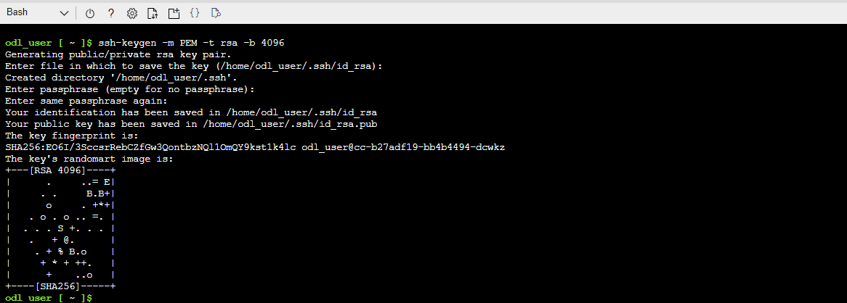

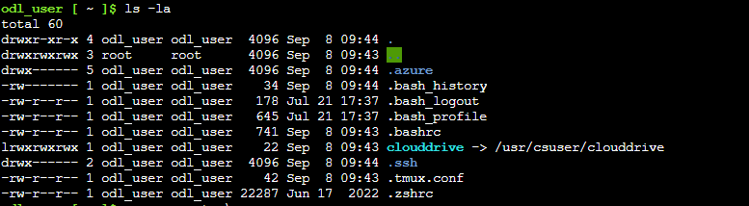

Step 2: Create the virtual machine using the key

- Execute the following command to create the VM:
az vm create --resource-group RG02 --name VML --image UbuntuLTS --admin-username simpli --ssh-key-value ~/.ssh/id_rsa.pub

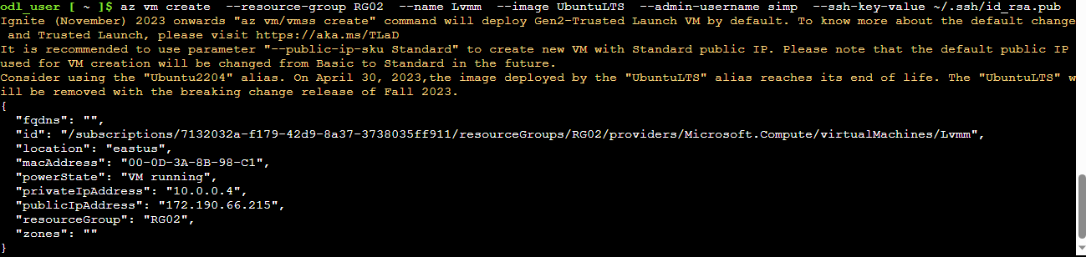

Step 3: Connect to the virtual machine

- Run the below command to connect to the VM:
ssh -i ~/.ssh/id_rsa <username>@<ip address>

When Windows appears, provide yes to the below query:
Are you sure you want to continue connecting (yes/no/ [fingerprint])? yes

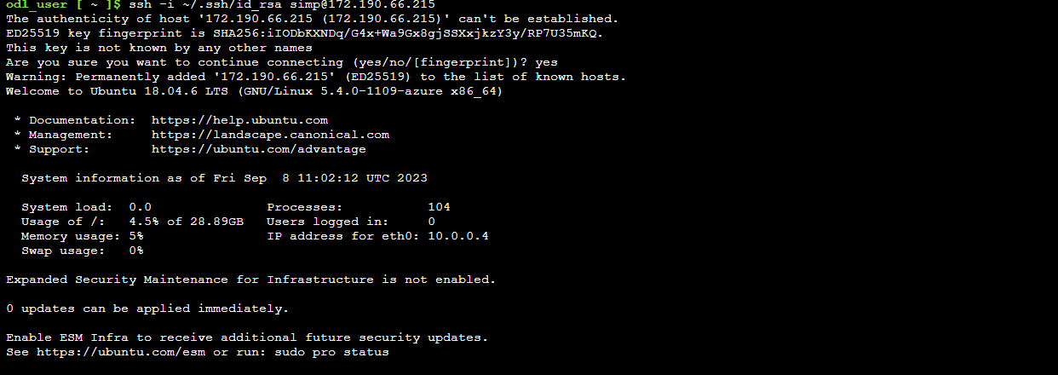

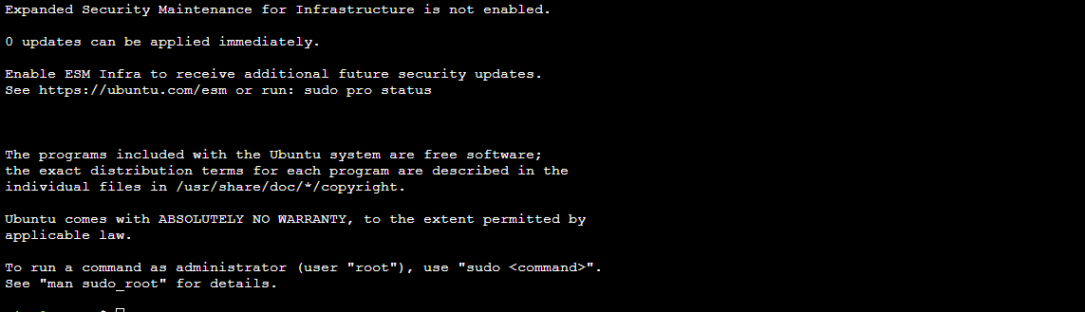

You have now successfully connected to a Linux-based virtual machine using the SSH protocol.

